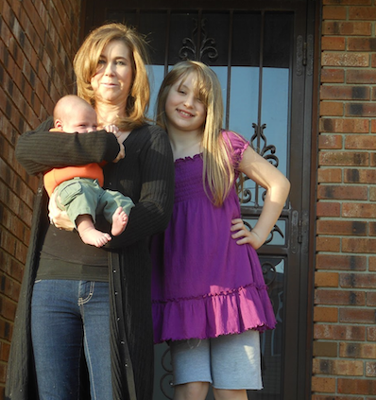

At My Sister’s House

My sister, my nephew, and I stand in front of my sister’s brown brick house on a sunny spring morning. My sister wears blue jeans and a black t-shirt with a long black sweater that goes down to her knees. Her blonde hair falls over her right eye and cascades over her shoulders. She’s holding my baby nephew in her arms. He wears an orange shirt, khaki pants and no shoes. His bare feet are probably chilly. I am wearing a purple blouse, a favorite shirt of mine, with sky blue shorts. My hand is left is on my left hip. My blonde hair is the longest it has ever been and draped over my left shoulder. The morning sunshine invites us to take a walk together!

Not a GREAT example

This is a picture of my sister, niece, and nephew standing in front of their brown brick house on a beautiful day. My nephew is just a baby in the picture. My niece is twelve. My sister is 33 I think. They are all happy and smiling. My nephew isn’t wearing any shoes.

