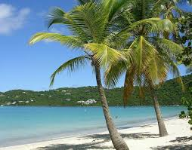

Beach at Hawaii

The brilliant blue ocean ripples with white-topped waves. The waves crash against the pristine beach. The sky shines like a crystal blue marble. A line of wispy white clouds hovers near the horizon of the wide ocean. A small palm tree stands straight on the golden sand of the beach. The tree’s shadow is the one cool spot on the hot sand. A taller palm tree sways in the wind, providing a refreshing breeze. Its leaves make a rippling sound. The invigorating scent of fresh salt water fills the sun-warmed air. The beach beckons you to relax and have fun in the sun.

